Week 12 lab

By

Ujjwal Bhasin - 2000389272

Advanced Databases

Maziar

1. **Database ‘Week12Lab’ Created.**

**CREATE DATABASE Week12Lab;**

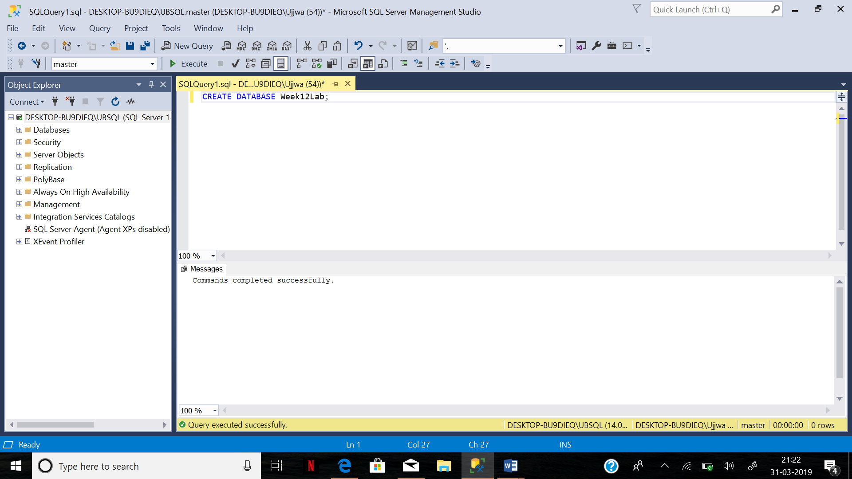

1. **Create tables ‘Customers’ and ‘CustomerLogs’**

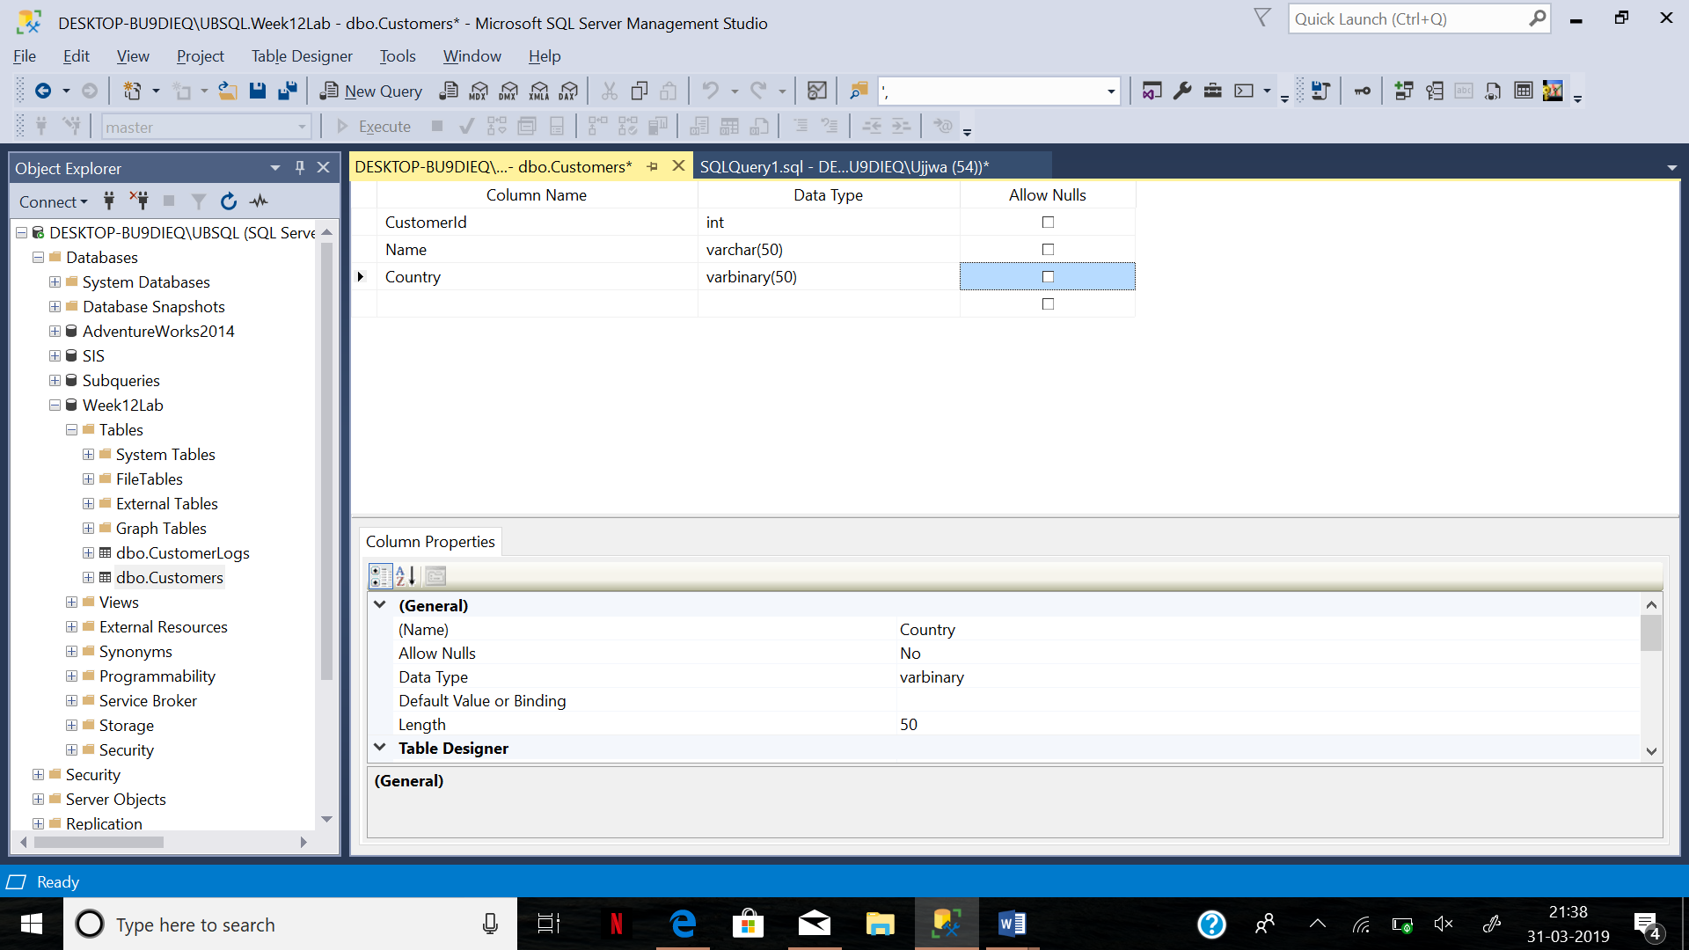

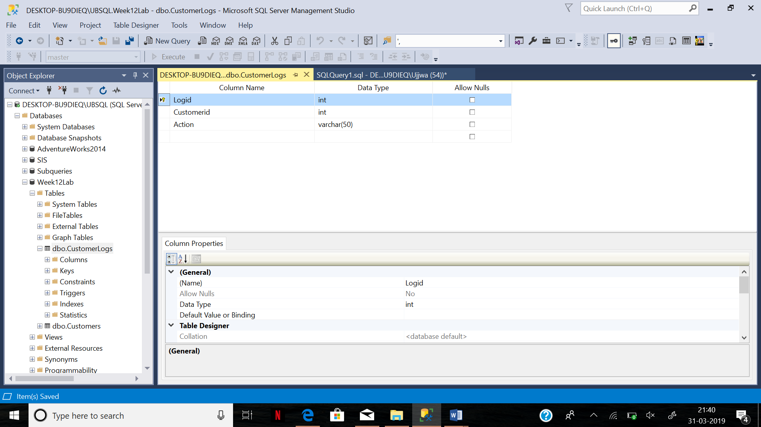

1. **TRIGGER – INSERT**

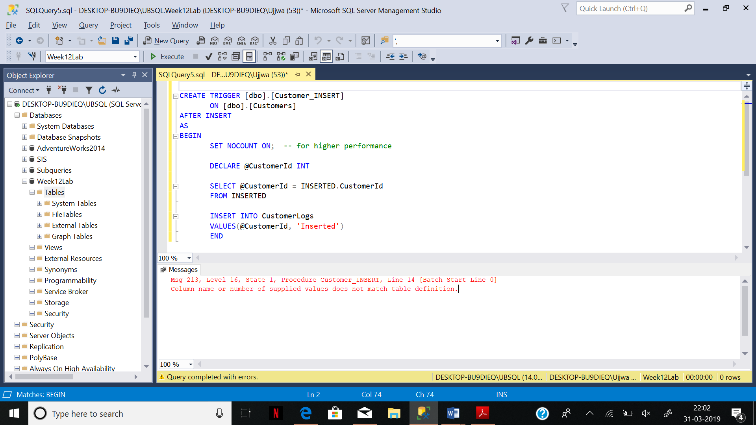

1. **TRIGGER – DELETE**

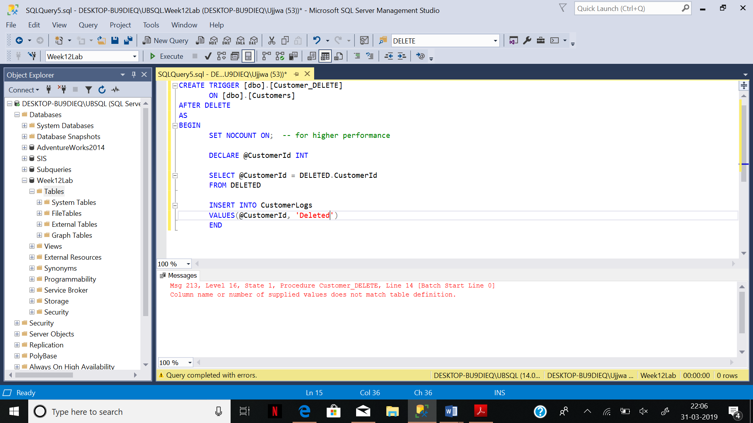

1. **Insert 8 rows in customers table**
2. INSERT INTO Customers VALUES (1, 'ub', 'la');
3. INSERT INTO Customers VALUES (2, 'Ja', 'a');
4. INSERT INTO Customers VALUES (3, 'G', 'I');
5. INSERT INTO Customers VALUES (4, 'B', 'ia');
6. INSERT INTO Customers VALUES (5, 'Rp', 'dia');
7. INSERT INTO Customers VALUES (6, 'Ma', 'Ia');
8. INSERT INTO Customers VALUES (7, 'Da', 'Ia');
9. INSERT INTO Customers VALUES (8, 'M', 'Ia');

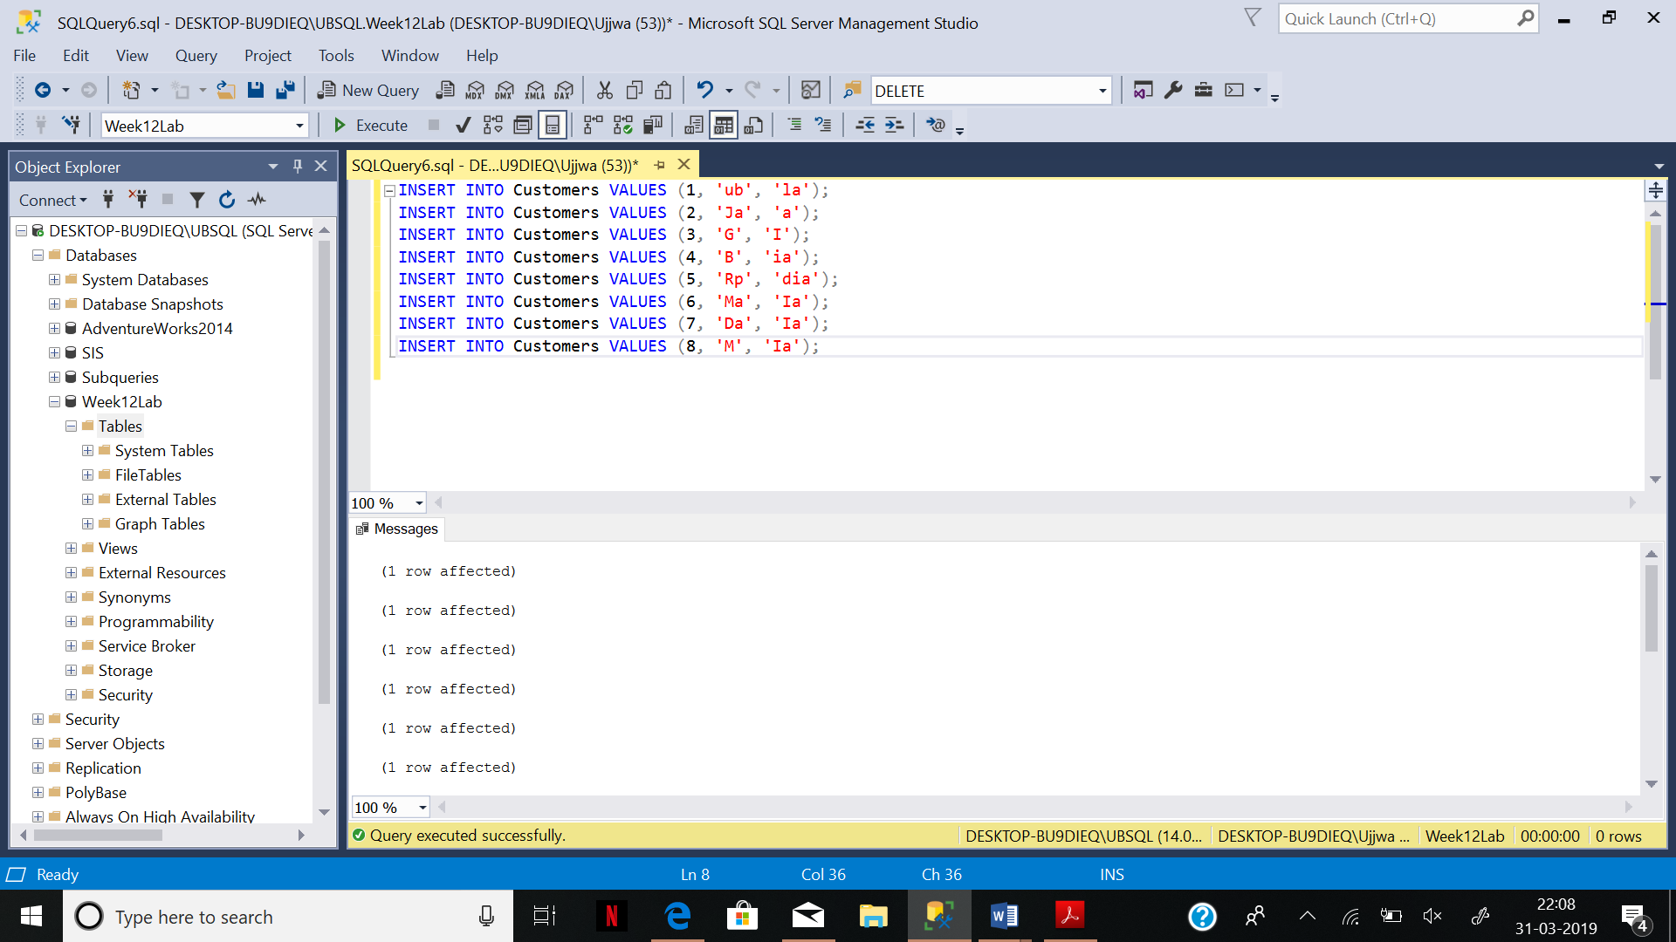

1. **DELETE 3 ROWS FROM CUSTOMERS TABLE**
2. DELETE FROM Customers
3. WHERE CustomerId = 1;
4. DELETE FROM Customers
5. WHERE CustomerId = 2;
6. DELETE FROM Customers
7. WHERE CustomerId = 3;

